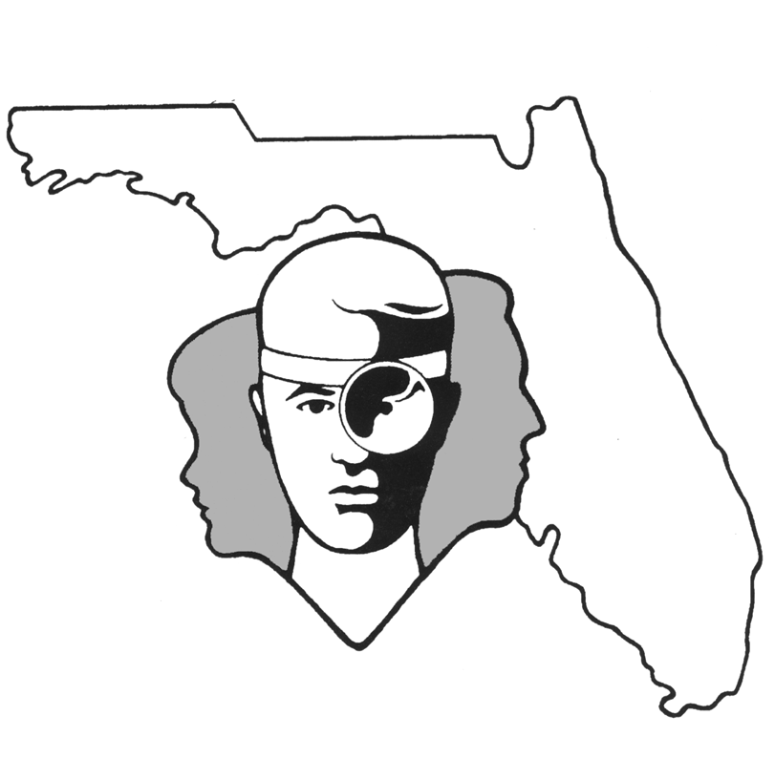
TALLAHASSEE EAR, NOSE & THROAT - HEAD & NECK SURGERY, P.A.

www.TallyENT.com Phone: (850) 877-0101

PAROTIDECTOMY or SUPERFICIAL PAROTIDECTOMY

Parotidectomy is the medical term for an operation to remove all or part of the parotid gland. The parotid gland is one of the “spit” glands and is located in front of the ear. This is the gland that swells with the mumps. A parotidectomy is typically advised when one has a mass within the parotid gland. Roughly 80% of these masses are benign and approximately 20% are malignant. Since malignant lesions can spread and be deadly, it is obvious why they should be removed. It may not be as obvious why a benign lesion should be removed. First of all, a small number of these lesions can later degenerate into malignant lesions. It is preferable to remove these while they are still benign. Secondly, most of the benign lesions continue to grow and can begin to cause problems just because of their size. By the time they enlarge and become problematic, they are more difficult and risky to remove. We therefore prefer to excise them when they are initially detected and are smaller in size. The surgery is called a superficial parotidectomy. This operation is best performed by head and neck specialists with extensive experience. There is certainly very little risk to one’s life from this sort of surgery, but there are certain other risks of the surgery which would be helpful to explain.

One type of incision is made in front of the ear, curving behind the lower jaw, and then curving forward in the upper neck along a neck crease. An alternate incision goes in front of, behind, and under the ear – a facelift incision. Your surgeon will choose which is best. The incision is made so that the skin of the face can be reflected forward to expose the entire gland. The nerve to the face, which controls all movement on one side, goes through the middle of the gland. This nerve must be identified and carefully preserved. Most tumors are in the outer half of the gland and by taking out the entire outer half, very high cure rates, on the order of 95-98%, are possible.

The chance of temporary injury to the facial nerve is less than five percent. Usually if the nerve does not work postoperatively this is only temporary. On rare occasions, however, permanent paralysis could follow a routine operation (less than 1 out of 1,000). This would result in drooping of the face on that side. The eyelids may not close and may require corrective surgery. The nerve is never intentionally cut unless it is known preoperatively that the tumor is malignant. We typically do fine needle biopsies as part of the work-up before surgery to determine if the tumor is malignant. Based on the results of this test, we will have discussed preoperatively the probability of intentionally sacrificing the facial nerve.

Numbness to the ear and sometimes surrounding tissue on the side of the surgery can be expected to occur routinely because the main nerve that supplies sensation to these areas may be cut in order to remove the lateral half of the gland. Most people have some or total return of feeling, however, within six to twelve months after surgery.

Another change that can occur after a parotidectomy is facial sweating in the area of surgery while eating. This is called Frey’s syndrome and is caused when nerves which previously supplied the parotid gland grow into facial sweat glands postoperatively. When you eat, these nerves cause sweating, whereas previously they would have stimulated the parotid or “spit gland” to make saliva. This is usually not a problem unless a lot of make-up is worn. There are some treatments which can be helpful if you are one of the very few people who are bothered by this (less than 1 out of 100).

We always talk about bleeding and infection with any surgical procedure. Infection occurs less than 1 out of 100 times. Bleeding rarely occurs. In order to prevent any problems with bleeding, we insert drains that will be in place for about 48 hours postoperatively. This usually prevents any of the problems which typically are associated with bleeding.

Many people ask if their mouth will be dry because of removal of the gland. Usually this is not the case because the other glands make up for the loss of any single gland.

Your surgeon will decide if you will go home the same day of the procedure or if you will be kept in the hospital postoperatively for a few days. At home, you should clean the incision two or three times a day with Peroxide and a Q-Tip, and then coat it with an antibiotic ointment such as Polysporin. The sutures will be removed in the office five to eight days after your surgery. It is typical for patients to go home with a drain in their neck, which will remain there for the first few days. According to your surgeon’s direction, the drain will be removed in the office. Instructions for proper care at home will be covered prior to leaving the hospital.

We hope this information has been helpful. It is meant to be informative and not to cause concern about the surgery. Obviously, you may have specific questions which we will be more than happy to answer at any time.

